**16.**

**AIM:** To design Turing Machine using simulator over the set {a,b} to accept the input string anb2n.

**Diagram:**

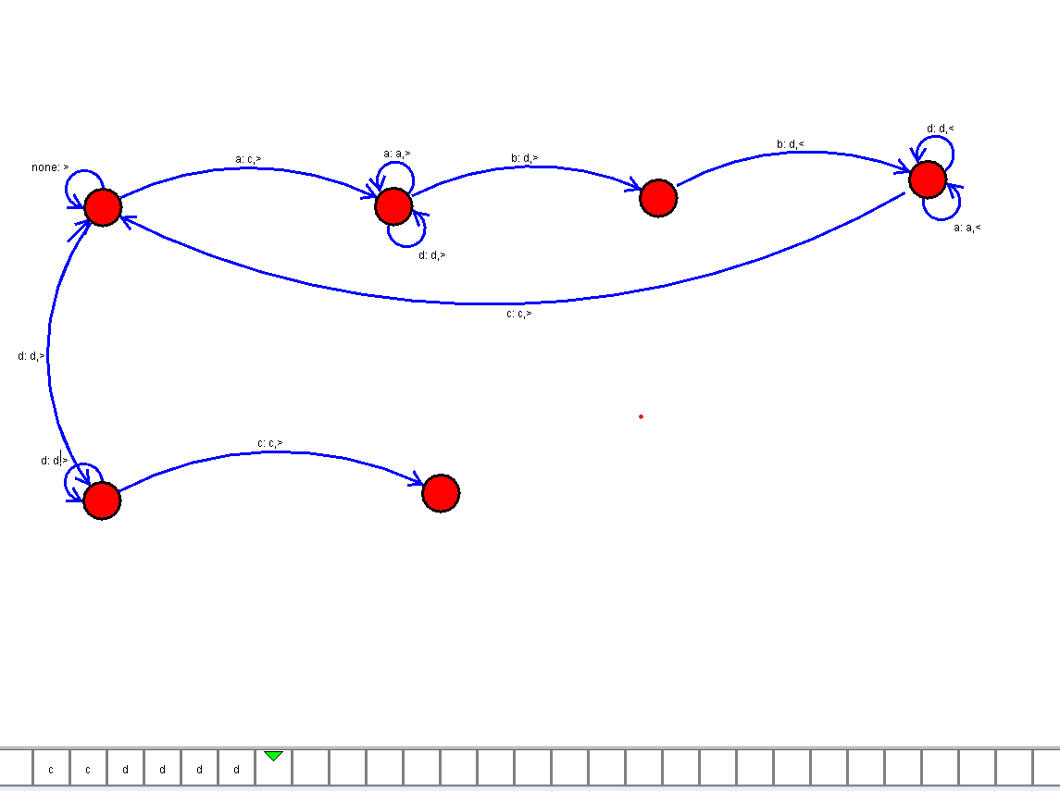

**Result:**

Thus, successfully executed Turing Machine using simulator over the set {a,b} to accept the input string anb2n